# Download code.

# Import project.

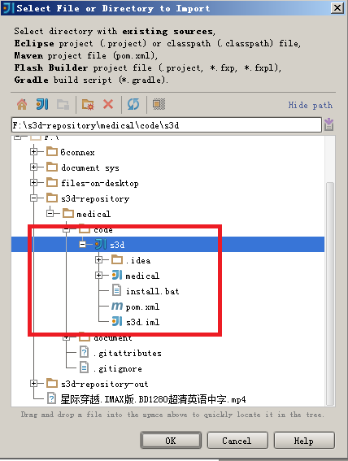

# Configure maven (can be omitted) or using by default.

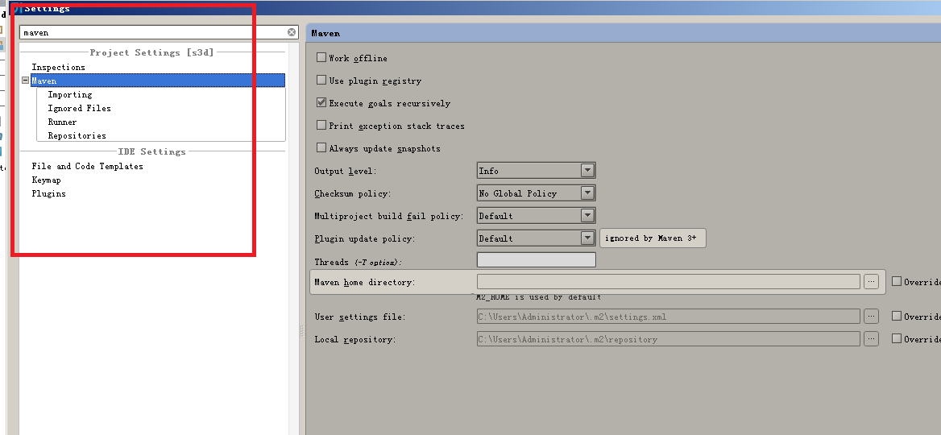

# Configure web

## open

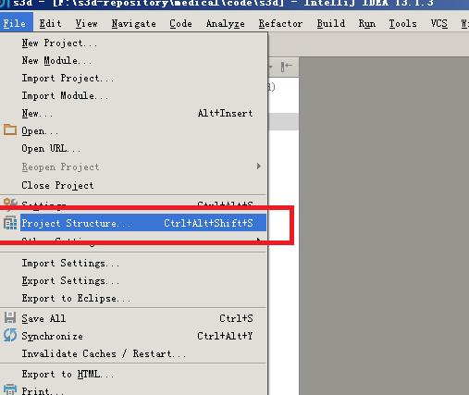

4.2 Navigate to modules ,highlight medical and click signal “+”

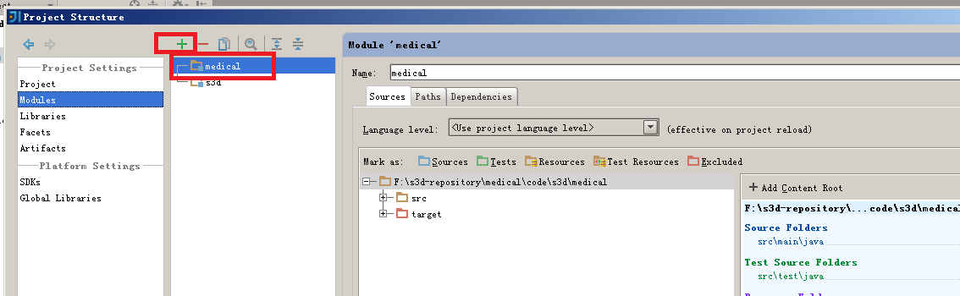

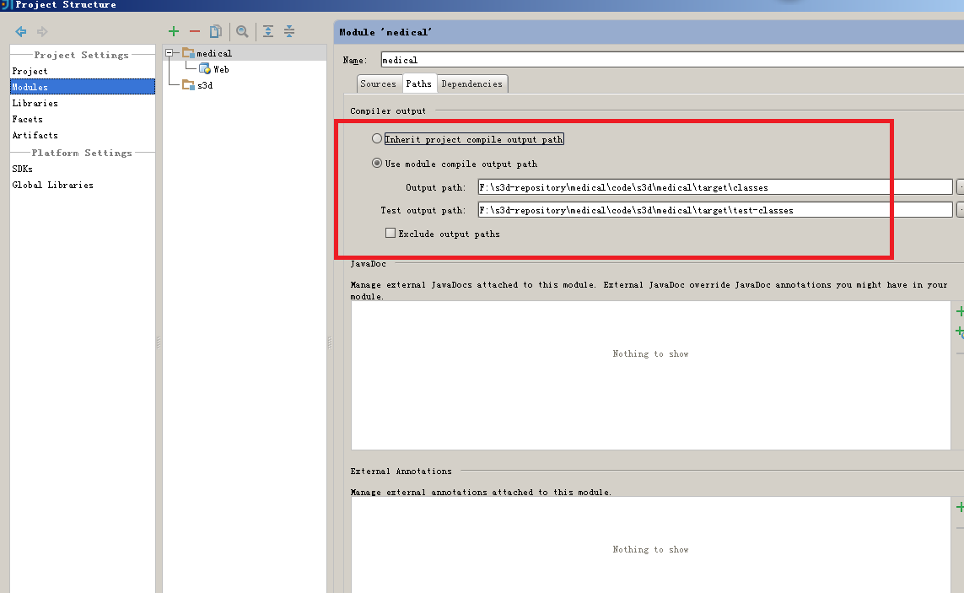

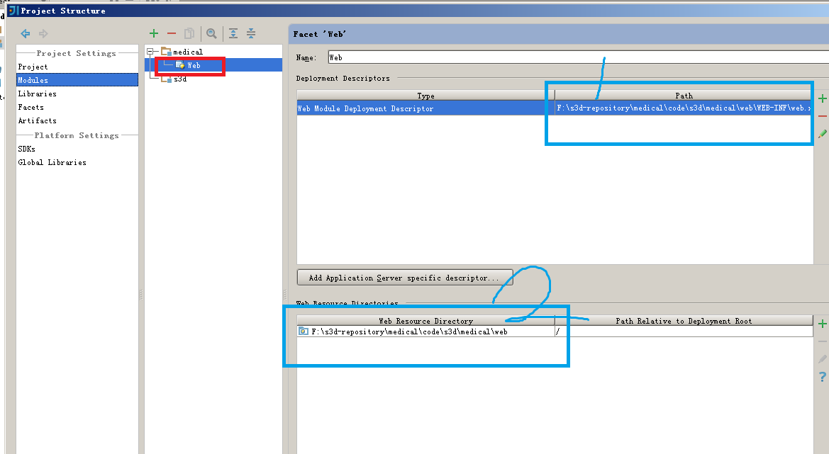

* 1. Modify values of Number1 and Number 2 by referring to

medical\src\main\webapp\WEB-INF\web.xml

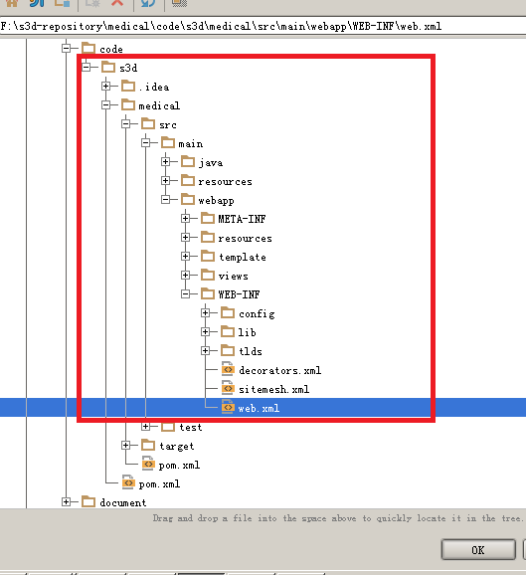

medical\src\main\webapp

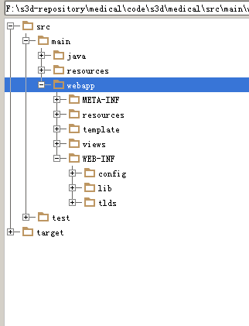

* 1. Idea gives promotion for add new artifacts.

# Facets to check values configured in modules and fix its error by adding new artifacts.

# 

# Click Fix

# 

